|  |  |
| --- | --- |
| Course Name | ITD 2313 – Script Programming |
| Instructor | Mark L. Pranger |
| Student Name | Thomas Webb |
| Due date | 5/13/2025 |
| Grade | Put grade earned here |
| Grading Comments | Put instructor comments here |

Page 34   
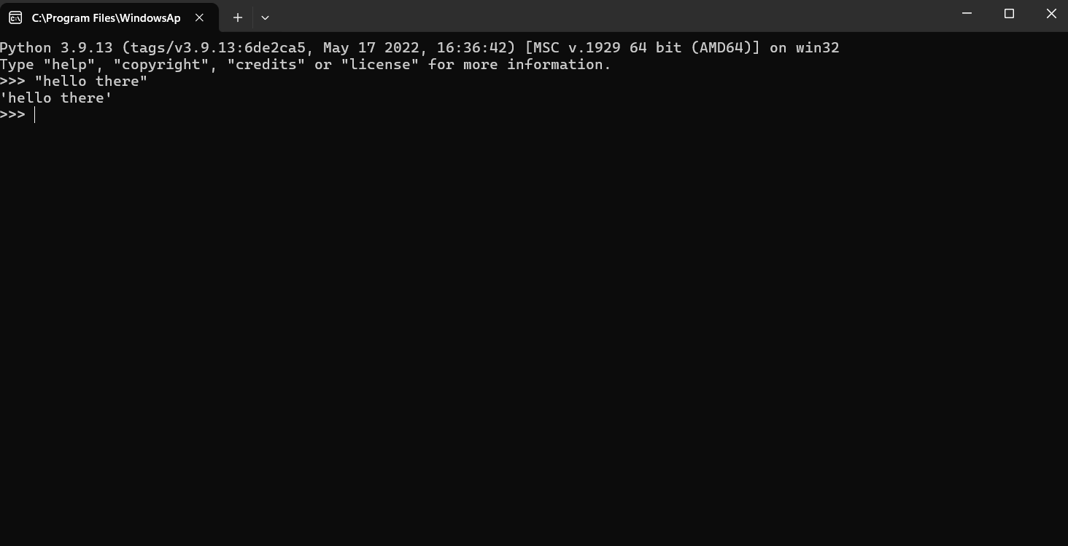

The Example code

The Second Example code

Page 35   
The code

The second example code Used

Page 36

Page 39  
  
1  
a. 12

b. Pi

c. $7.52

d.13.8 Billion years old   
  
2.  
Int means a number that is either negative that doesn’t have a decimal or a fraction  
Float represents numbers that have either a decimal or a fraction

3

1. 3.5576e + 10
2. 7.832e – 03
3. 4.3212e0

4.

$ is 36

& is 38  
  
  
Page 40  
  
  
Page 41

Example codes

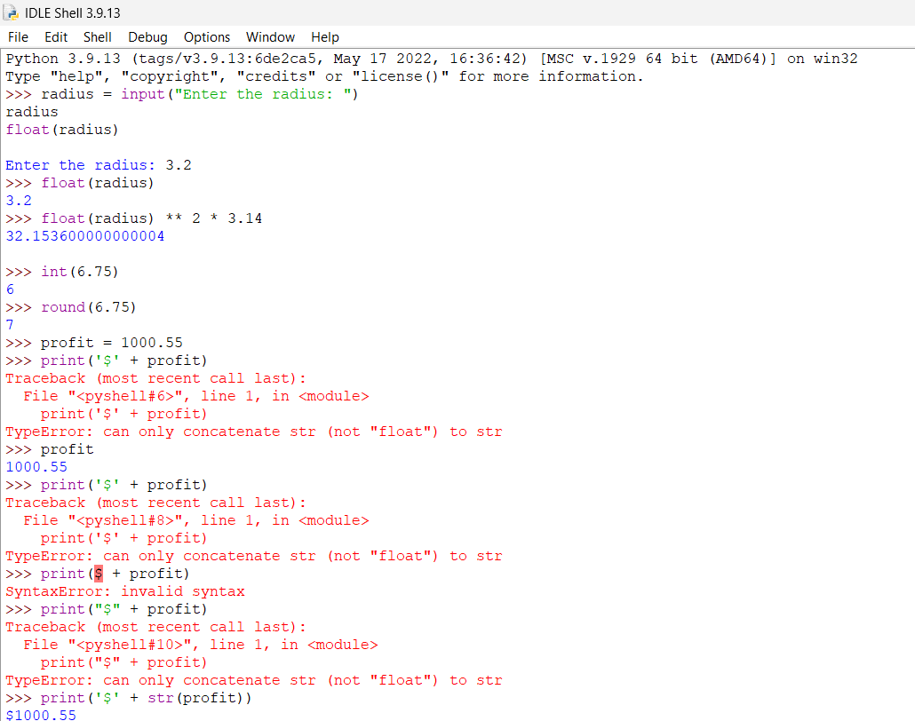

Page 42